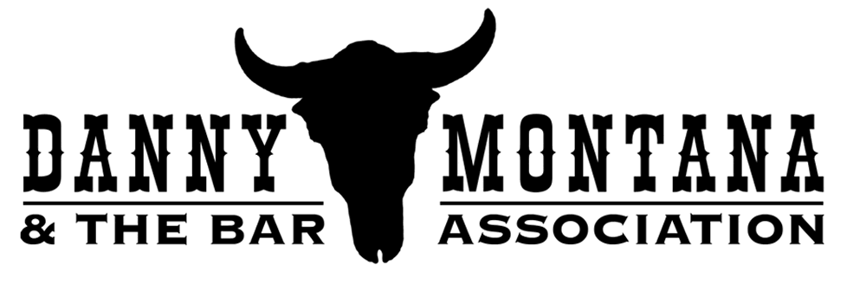

What they’re saying about Danny Montana & the Bar Association:

- “It was a blast, and you guys were great. Everyone dug it. We'll do it again... Have a good Rancho Nicasio show. Thank the boys for me.”
-- e-mail from Huey Lewis, following a 2-night stint opening for Huey Lewis and the News at the Mountain Winery in Saratoga

- "...Far and away the hottest country band around."
-- Marin Beat column, the Pacific Sun, 9/26/2008

- What a band – I especially like the instrumental outro on “Callin Caroline.” Hot! Hot! Hot! One of the best C&W bands I've heard in ages.
--North Bay music writer/reviewer Terry Hansen (after listening to demo tunes on web site July 2006)

- "You guys were smoking hot...Don't forget us when you're rich and famous!"
--Mike McShea, Peri's booking (following the Peri’s Hurricane Katrina benefit).

- "The Bar Association is about the piggiest band I've heard around here for a while..."
--Gordy Hall, local KPIG Radio marketing rep, in an email requesting The Bar Association's participation in the "Piggie Days" event in Fairfax.

- "These guys brought the house down at the hurricane benefit! Don't miss this
superb band…”
-- From the Peri's November 2005 Calendar "Who's Who" section

- You guys rocked the house in Point Reyes. Thank you so much for coming out and playing…”
--Jerry Lundsford, DJ, “The Hippie From Olema Show”,(KWMR Radio) and Western Weekend organizer, following Western Weekend, 2006

Contact: Cyndi Cady / (415) 717-7848 / cyncady@soundbureau.com

Web Site: www.dannymontanaband.com

