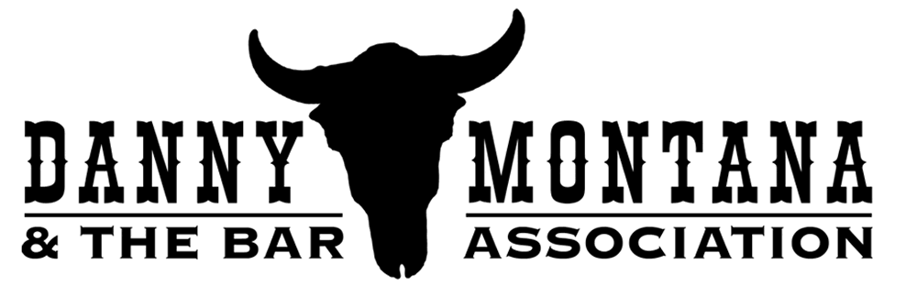

MARIN BAND DELIVERS COUNTRY MUSIC WITH A WEST COAST FEEL

Woodacre, CA -- Danny Montana & the Bar Association (www.dannymontanaband.com) have been building a strong local following, no doubt due to their infectious brand of country music and western swing, a rock-solid rhythm section and a set of dynamite soloists guaranteed to get things hopping.

There's not a rookie in this band, which combines players from well-known local groups, legendary Marin bands of the '60s and '70s, and even one superstar act.

With a playlist featuring traditional country music and western swing, and a roster of great original country tunes from good friend former Clover lead man and current Nashville songwriter Alex Call (best known for "867-5309/Jenny"), the band is pushing to broaden their horizons, focusing on community events and concert series.

The Bar Association are:

DANNY MONTANA, lead vocals & rhythm guitar (Hereford Hartstringers (a regular opener for notable Marin band Clover), Little Big Band);

LARRY CRAGG, pedal steel (Larry, a nationally-known guitar tech, plays with and works for Neil Young, and is the former owner of legendary Prune Music in Mill Valley...it’s hard to find a nationally touring musician who doesn't know Larry);

PHIL RICHARDSON, fiddle (Hereford Hartsringers, Norton Buffalo, Hot House Swing Band);

DANA OLSEN, lead guitar (Spark & Cinder, Area 51, and Primal)

TIM BUSH, bass (Chuck Day, TMJ, Rusty Evans, Sweetie Pie & the Doughboys and
many more...a strong local presence);

BEAU FAW, drums (Lee Press-On and the Nails, Magnum Brutes, the Oppressors, 6L6)

# # #

Contact:
Cyndi Cady
(415) 717-7848
cyncady@soundbureau.com

