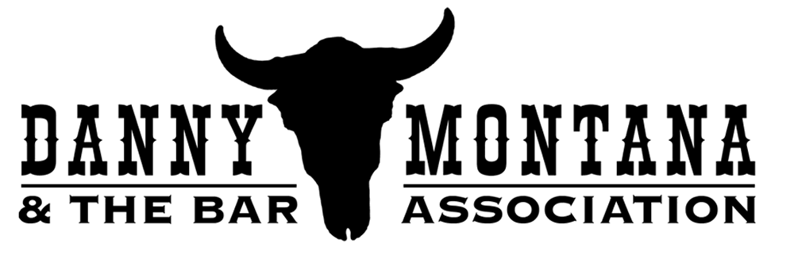
Band Bios
DANNY MONTANA, lead vocals & rhythm guitar (Hereford Hartstringers, Little Big Band). Bandleader Danny Montana blames his affinity for country music on a Columbia Record Club error that sent him George Jones' Greatest Hits instead of the Kinks' Greatest Hits when he was 12 years old. In the late '60s, he joined the Hereford Hartstringers with Phil Richardson, Sean Hopper and Terry Hansen.

The Hartstringers, along with Clover members Alex Call, Johnny Ciambotti (Carlene Carter, Lucinda Williams) and John McFee (Doobie Bros.), Steve Bonucelli (Flying Circus), and others, including a then-unknown harmonica player named Huey Lewis (responsible for nicknaming Danny "Danny Montana"), formed a 12-piece bluegrass band (“The Big Band”). Danny was a regular at Huey's infamous "Monday Night Live" sessions at Uncle Charlie's in the 70's and later played with harmonica whiz Norton Buffalo.

Danny drew on his association with the many excellent musicians he has known over the years to create Danny Montana and The Bar Association in 2005, building his “dream team” with some of the finest players in the Bay Area.

LARRY CRAGG, pedal steel (Neil Young, Nils Lofgren, Clarence Clemens Band, the Bulls). An established guitar technician since 1969, and Neil Young's guitar tech since 1973, Larry has played banjo, pedal steel, 12-string guitar, keyboard, synth-drums, baritone sax and hurdy-gurdy on tours with Neil.. In the early 90's, Larry toured the US and Europe with Nils Lofgren, playing guitar and keyboard. During that same time, he played baritone sax in the Clarence Clemens band. In the 90's, he played pedal steel in a local band, The Bulls, with Alex Call, Dave Jenkins and Lorin Rowan. Today, Larry's focus is the pedal steel, and when he’s not on the road with Neil Young, he's playing with the Bar Association.

PHIL RICHARDSON, fiddle (Hereford Hartstringers, Norton Buffalo, Hot House Swing Band, Ain’t Misbehavin’); Raised in Mill Valley, California, Phil started playing folk guitar at four, and had his first paying gig at age 12. After studying music at the Paris Conservatory, Phil returned to the Bay Area, performing, touring and recording on electric violin with Norton Buffalo. He has played with Bonnie Raitt, Kate Wolf, Kris Kristofferson and Smokey Robinson, and recorded with the legendary Link Wray. Phil’s solid musical background serves him well when he’s whipping out hot fiddle licks with the Bar Association.

DANA OLSEN, lead guitar (Ralph Shine Blues Band, Steve Cook & Friends, Spark & Cinder, Area 51, The Blues Movers, and Primal). At 17, he lied about his age to get a union card in Local 47 to play gigs in Los Angeles. He started playing country music in earnest when Les McDaniels hired him to play guitar for the Western Lights band. Feeling that some of the best songwriting was happening in country music, he became hooked on the genre, and now he’s tearing up the stage playing Telecaster for the Bar Association.

TIM BUSH, bass (Chuck Day and the Burning Sensations, WTJ Trio, Rusty Evans, Pack of Wolves, Sweetie Pie & the Doughboys and many more). Experienced in blues, country and rock, the charming and dexterous Tim Bush has made his mark in a variety of styles, and today he is one of the most sought after bassists in the booming Fairfax, CA music scene. Introduced to country music by his ranch-raised Texan father, Tim spent his childhood listening to many of the same musical styles he’s now playing with the Bar Association.

BEAU FAW, drums (Lee Press-On and the Nails, Connie Champagne and Her Tiny Bubbles, John Belushi Memorial Orchestra, Acme Swing Company, The Oppressors, 6L6). At 12, Beau was already playing professionally -- with an all-girl band (they had to put a fake mustache on him so that he could play in nightclubs) -- and doing rim shots for Milton Berle. He even played for stripper Tempest Storm when she danced at age 80 at the Mitchell Brothers Theater. He blames his kids, bass players Jake (6L6) and Sam, for getting him into country music, and today, Beau provides a rock-solid foundation to the Bar Association’s rhythm section.
Contact: Cyndi Cady / (415) 717-7848 / cyncady@soundbureau.com
Web Site: www.dannymontanaband.com

