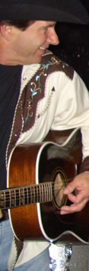 | Danny Montana &  THE BAR ASSOCIATION  TUNES:  1. Callin’ Caroline (Worley, Leslie, Rogers)  2. I’m Pourin’ Whiskey on Her Memory  (Call, Johnson)  3. Stand Back (Call, Johnson)  BOOKING:  Cyndi Cady (415) 717-7848  cyncady@soundbureau.com  www.dannymontanaband.com  BAND:  On cover, left to right: Tim Bush , bass;  Beau Faw, drums; Larry Cragg, pedal steel;  Danny Montana, lead vocals & rhythm guitar;  Phil Richardson, fiddle, vocals;  Dana Olsen, lead guitar, vocals
Danny Montana &
THE BAR ASSOCIATION

TUNES:
1. Callin’ Caroline (Worley, Leslie, Rogers)
2. I’m Pourin’ Whiskey on Her Memory
(Call, Johnson)
3. Stand Back (Call, Johnson)
BOOKING:
Cyndi Cady (415) 717-7848
cyncady@soundbureau.com
www.dannymontanaband.com

BAND:
On cover, left to right: Tim Bush , bass;
Beau Faw, drums; Larry Cragg, pedal steel;
Danny Montana, lead vocals & rhythm guitar;
Phil Richardson, fiddle, vocals;
Dana Olsen, lead guitar, vocals

